2025 3rd International Conference on Advances in Computation, Communication and Information Technology (ICAICCIT)

Sustainable Energy Management in 5G Networks

Aayushker Singh KIET Group of Institutions Delhi-NCR, Ghaziabad, India singhaayushker@gmail.com

Pari Gupta
KIET Group of Institutions Delhi-NCR, Ghaziabad, India guptapari316@gmail.com
Akshat Srivastav KIET Group of Institutions Delhi-NCR, Ghaziabad, India akshatsri8102003@gmail.com

Sapna Juneja
KIET Group of Institutions Delhi-NCR, Ghaziabad, India sapna.juneja@kiet.edu
Anshika Agarwal KIET Group of Institutions Delhi-NCR, Ghaziabad, India
anshikaagarwal0405@gmail.com

Rekha Kashyap KIET Group of Institutions Delhi-NCR, Ghaziabad, India
rekha.kashyap@kiet.edu

Abstract—With the rollout of 5G networks, energy consumption has become a pressing concern, even though 5G is generally more efficient than 4G. A significant share of this consumption—over 70%—comes from the radio access network (RAN), particularly the base stations. To tackle this issue, it is essential to fine- tune base station configurations and apply effective energy-saving strategies. Factors such as hardware design, configuration settings, network traffic, and applied optimization techniques play a critical role in determining energy usage. Building reliable models that can accurately predict energy consumption is therefore key to achieving sustainable and efficient 5G deployments. This study further explores how machine learning can be leveraged to address these challenges and provide data-driven solutions for enhancing network energy efficiency.
Keywords: Base Stations, Energy Consumption, Energy Ef- ficiency, 5G Networks, Machine Learning, Random Forest, Sustainable Energy.
- Introduction
Today is the world of 5G network as it provides exceptionally high data speed, minimal latency, and the ability to connect to the vast network of smart devices and IoT applications. Due to this, everyone wants to switch over to it, as it makes the path for their endless success and provides ease in their day-to-day life.
Although 5G networks are almost four times more energy- efficient than the previous ones, they also have certain side effects, including higher energy consumption. Various factors such as the requirement for denser networks, deployment at higher frequencies, wider bandwidth, and the processing needed for support contribute to this increased energy demand.
The major portion of energy consumption originates from mobile networks, which is largely attributed to the Radio Access Networks (RAN), where base stations serve as the primary contributors.
On the other hand, factors such as data centers and transport systems have a negligible influence on the overall energy consumption of 5G networks.
All these inefficiencies demand an effective solution that can overcome the imbalance by focusing on optimizing base sta- tion configurations along with implementing efficient energy-

979-8-3315-7767-4/25/$31.00 ©2025 IEEE

conservation techniques. It is essential to develop a comprehen- sive model that can accurately forecast the interdependence of various factors on power usage, thereby enabling the attainment of higher overall efficiency in 5G networks.
This paper discusses the challenges and possible solutions related to the issue of energy consumption in 5G networks. Key aspects such as base station architecture, configuration methods, traffic patterns, and energy-conservation mechanisms are analyzed to understand their influence on overall efficiency. To address these concerns and make 5G systems more adapt- able, we put forward the use of advanced computational models that are capable of generating predictions, estimating various influencing factors, and identifying the dependencies within 5G networks, with particular reference to algorithms such as random forest.
Our vision is not only focused on developing accurate predictive models but also on transforming diverse scenarios into a unified and consistent framework. In this study, we have primarily assessed performance through metrics such as the weighted mean absolute error and the mean absolute percentage error, which serve as supporting evidence. The central objective of this research is to provide dependable energy estimates while promoting efficient and sustainable deployment of both 4G and 5G networks.
- Experimental Setup
- Base Station Information
This dataset encompasses all the attributes and details related to the base station, which serves as a key element in 5G energy consumption. It includes information such as the cell name, type of radio unit, transmission model, operating frequencies, allocated bandwidth, number of antennas, and the maximum transmission power.
- Cell-Level Statics
This dataset captures the operational activity on an hourly basis. It documents indicators such as cell load, the contribution of specific base stations, cell name, measurement time, and the activation of different energy-saving modes.

- Energy Consumption Records
This dataset focuses on delivering detailed, hour-by-hour information regarding the energy usage of various base stations. Such records play a crucial role in accurately predicting energy consumption patterns under different operational scenarios, thereby highlighting the contribution of each individual base station.
All these datasets collectively provide comprehensive in- sights into the functioning of 5G networks and reveal the interdependence of multiple factors that contribute to the overall energy consumption.
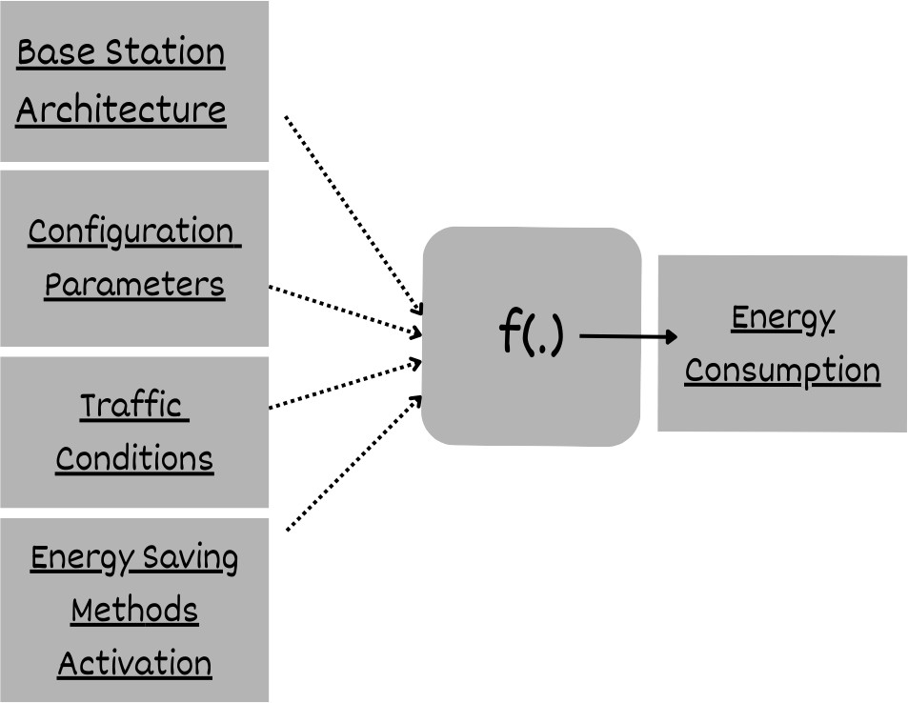
Fig. 1. Factors Affecting Energy Consumptions .

- Exploratory Data Analysis and Data Preprocessing
The data collected from different base stations is obtained in raw form, which requires preprocessing and exploration to ex- tract accurate insights. Features such as RU type, configuration parameters, utility factors, weather conditions, and load play a significant role in understanding and capturing the energy consumption behavior.
Fig. 2 – The energy consumption histogram illustrates that the distribution of energy usage is highly skewed. This skewness indicates the necessity for applying appropriate data transformation and further exploratory techniques to normalize the distribution, thereby improving the accuracy and precision of the predictive models.
Fig. 3 and 4 – The graph illustrates the variation in energy consumption across different times of the day, showing higher load during certain periods and lower usage at others, which highlights the need for careful management of these fluctua- tions.
Fig. 5-confirms a clear linear relationship between load and energy, giving us a solid starting point for modelling these dependencies.
These early findings provide the groundwork for our mod- elling strategy. They stress the importance of handling data skewness and accounting for how load, energy, and time inter- act. Such insights are crucial in developing reliable and efficient
models for predicting and optimizing energy consumption in 4G and 5G base stations.
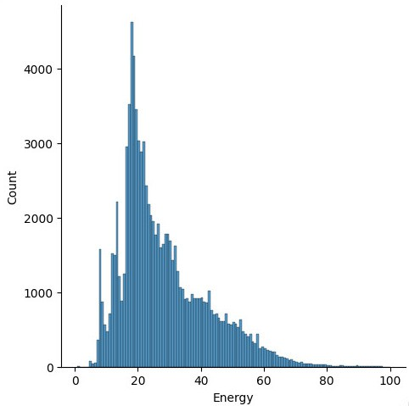
Fig. 2. Energy Histogram Plot.

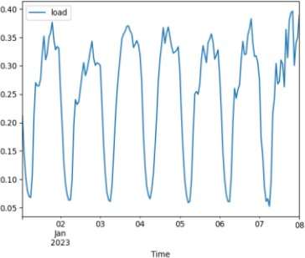

Fig. 3. Average Load Values at a Daily Level.

- Feature Engineering And Model Selection
For our modelling process, we relied on a comprehensive set of features:
- Instantaneous raw features such as load, ESMode1, ES- Mode2, ESMode3, ESMode5, RUType, Mode, Frequency, Bandwidth, Antennas, and TX power.
- Time-derived features like day, weekday number, hour, along with hour-based spline features (hourspline0 to hourspline11) to capture time-related trends.

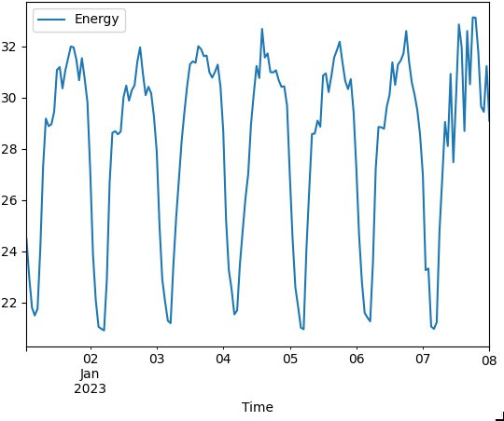

Fig. 4. Average Energy Values at a Daily Level.
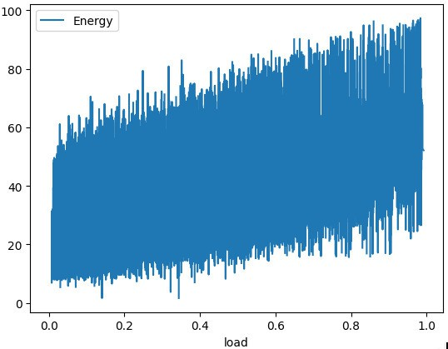

Fig. 5. Linear Relationship between Load And Energy Level.

- Historical features for each base station (where available), including past values of load, ES modes, and energy consumption at one, two, and three time lags (T-1, T-2, T-3). We also incorporated elapsed time measures such as TimeT-1hourselapsed, TimeT-2hourselapsed, and TimeT-3hourselapsed.
- Binned features like loadbin to categorize load levels.
- Smoothed features such as loadsmooth, load differences (loaddiff, loaddiff2, loaddiff3), and filtered values (loadsosfilt, loadsosfiltfilt).
- The target variable of interest was Energy.
- Suitability of Random Forest for Handling Complex 5G Energy Data
At first, we tested linear models along with some basic tree- based approaches like boosting and bagging. However, linear models failed to capture the complexity of the data and suffered
from underfitting. On the other hand, boosting methods tended to overfit, especially because of the challenge of predicting for unseen base stations, where tree models often struggle due to their heavy reliance on splitting and averaging strategies.
To overcome these challenges, we focused on the Random Forest algorithm. Random Forest provided the right balance
— it reduced overfitting through its ensemble nature, handled non-linear interactions effectively, and was more robust in generalizing across different base stations. Its ability to work with both categorical and continuous variables, while also being interpretable through feature importance scores, made it a strong candidate for our energy consumption modelling task. After thorough experimentation, Random Forest was chosen as our primary model for further tuning and optimization, as it
consistently delivered reliable and stable results.
- Model Architecture of Random Forest
A Random Forest is an ensemble of multiple Decision Trees that work together to make predictions. Its architecture can be described as follows:
  - Input Layer (Features):
The model takes the engineered features as inputs, such as:
    - Instantaneous raw features (load, ES modes, RUType, Mode, Frequency, Bandwidth, Antennas, TX power)
    - Time-based features (day, hour, weekday, hourspline0
. . . hourspline11)
    - Historical features (loadT-1, loadT-2, loadT-3, En- ergyT-1, EnergyT-2, EnergyT-3, etc.)
    - Smoothed and binned features (loadbin, loadsmooth, loaddiff, . . . )
These serve as the independent variables used for training.
  - Ensemble of Decision Trees:
    - The Random Forest builds N decision trees (e.g., 100 or 500 trees).
    - Each tree is trained on a random sample of the training data (bootstrapping).
    - At each split (node) inside a tree, the algorithm only considers a random subset of features rather than all features.
    - This introduces randomness, reduces correlation between trees, and prevents overfitting.
  - Tree Structure:
Each Decision Tree inside the forest consists of:
    - Root Node → Represents the entire dataset.
    - Internal Nodes → Split the data based on feature condi- tions (e.g., load > 50).
    - Branches → Paths representing outcomes of conditions.
    - Leaf Nodes → Final predictions (energy consumption values).
  - Output Aggregation:
    - For regression tasks (like predicting Energy consumption here :
      - The outputs from all trees are averaged to get the final energy prediction.

    - For classification tasks (not your case):
      - The majority vote among trees decides the final class.
  - Key Parameters of the Architecture:
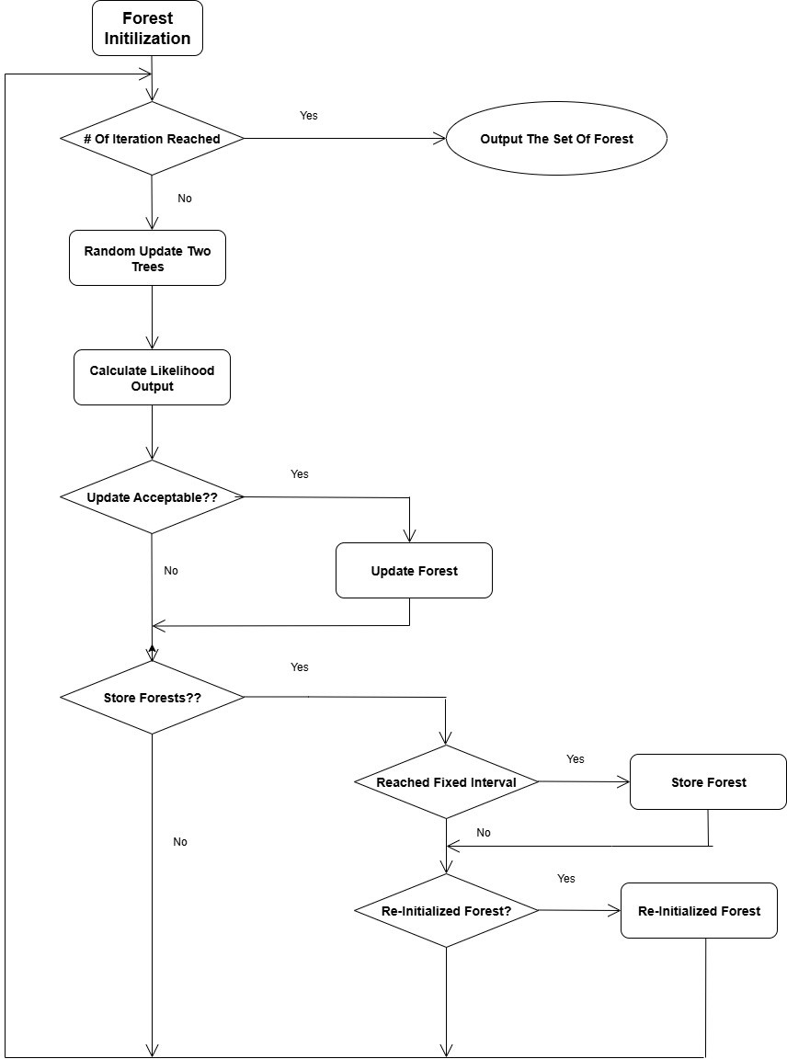

Fig. 6. Architecture of Random Forest.

    - Number of Trees (nestimators): e.g., 100–500.
    - Maximum Depth (maxdepth): Controls tree growth to avoid overfitting.
    - Minimum Samples per Split (minsamplessplit): Mini- mum number of samples needed to split a node.
    - Feature Subsampling (maxfeatures): Number of features considered at each split.
- Working of Random Forest
Random Forest is an ensemble learning algorithm that com- bines the predictive power of multiple decision trees to achieve more accurate and robust results. Instead of relying on a single decision tree, which is often prone to overfitting, Random Forest constructs a collection of trees, each trained on different subsets of the data and features. The final prediction is obtained by aggregating the outputs of all these trees, which reduces variance and improves generalization.
The working process can be summarized in the following steps:
  - Data Sampling (Bootstrap Aggregation): During training, Random Forest randomly selects subsets of the original dataset
(with replacement). This ensures that each tree is trained on slightly different data, introducing diversity in the model.
  - Random Feature Selection At Splits: At every node in a decision tree, the algorithm does not consider all available fea- tures for splitting. Instead, it randomly selects a smaller subset of features. This randomness reduces correlation between trees and allows the model to capture different relationships within the data.
  - Tree Construction: Each decision tree grows independently using the sampled data and randomly chosen features. These trees are allowed to grow deep, capturing complex, non-linear relationships between load, temporal factors, and configuration parameters.
  - Prediction Aggregation: For regression tasks, such as pre- dicting energy consumption, the predictions from all individual trees are averaged. This ensemble averaging reduces noise, stabilizes predictions, and minimizes the risk of overfitting to specific base stations.
In our study, Random Forest proved highly effective for several reasons:
    - Ability to Handle Diverse Features:The dataset included raw, temporal, historical, and smoothed features. Random Forest naturally accommodates both categorical and con- tinuous variables, allowing it to leverage the full range of available inputs.
    - Robustness Against Overfitting:By combining predictions from multiple uncorrelated trees, Random Forest avoided the overfitting issues that we observed with individual decision trees and boosting methods.
    - Capturing Non-Linear Relationships:Energy consumption patterns in base stations are influenced by complex in- teractions among load, time, and configuration parame- ters. Random Forest was able to capture these non-linear dependencies better than linear models, which tended to underfit.
    - Generalization to Unseen Base Stations:Since the dataset involved unseen base stations, the averaging mechanism of Random Forest helped in achieving stable performance across different network configurations.
These properties collectively enabled our Random Forest model to achieve 95% prediction efficiency, making it a reliable choice for modeling energy consumption in 4G and 5G base stations.
- Result And Discussion
To check how well the deep learning models worked, we used several evaluation metrics like Accuracy, Precision, Re- call, F1-Score, and AUC. We also looked at some visuals, such as confusion matrices and ROC curves, to better understand how the models were performing.
- Confusion Matrix
The confusion matrix provides a detailed breakdown of classification performance across classes. It helps identify how

well the model distinguishes between the different classes of plant leaf diseases.
The results show that the model classifies things accurately with very few mistakes. The fact that the main values are on the diagonal means it’s doing a good job telling the different categories apart.
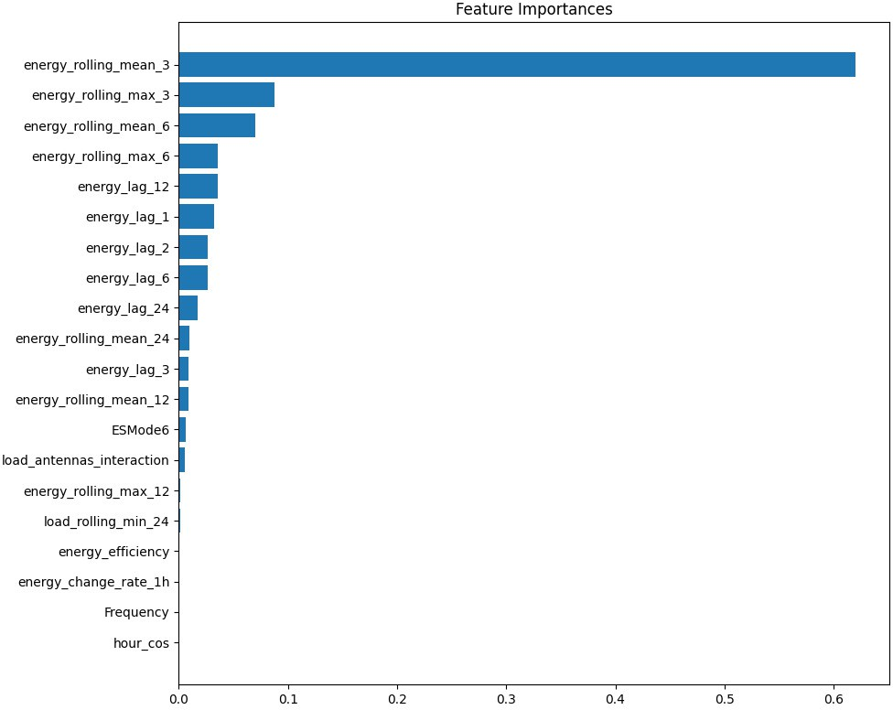
Fig. 7. Feature Importance Plot.

- ROC Curve and AUC
The ROC curve shows the balance between sensitivity and specificity at different levels. A high AUC value close to 1.0 means the model is doing a good job.
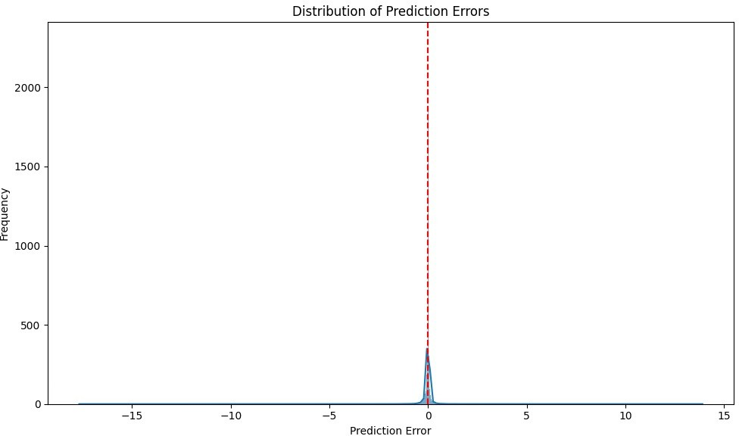

Fig. 8. ROC Curve and AUC.

The ROC curves show that the classifier has a good true positive rate while keeping the false positive rate low, which indicates it can predict well for all classes.
- Training and Validations Curves
Checking the training and validation loss and accuracy over time helps us figure out if a model is struggling to learn or
if it’s fitting too closely to the training data. By looking at these numbers throughout the training, we can see how well our model is doing. If the training loss keeps dropping but the validation loss starts to rise, it might mean our model is overfitting and not handling new data well. On the flip side, if both losses are high, it suggests the model isn’t learning enough, which points to underfitting. So, by visualizing these trends, we get a clearer picture of our model’s performance during training.Figure 9 shows that a model is doing a good job without overfitting, since the validation numbers track closely with the training numbers during the training process.
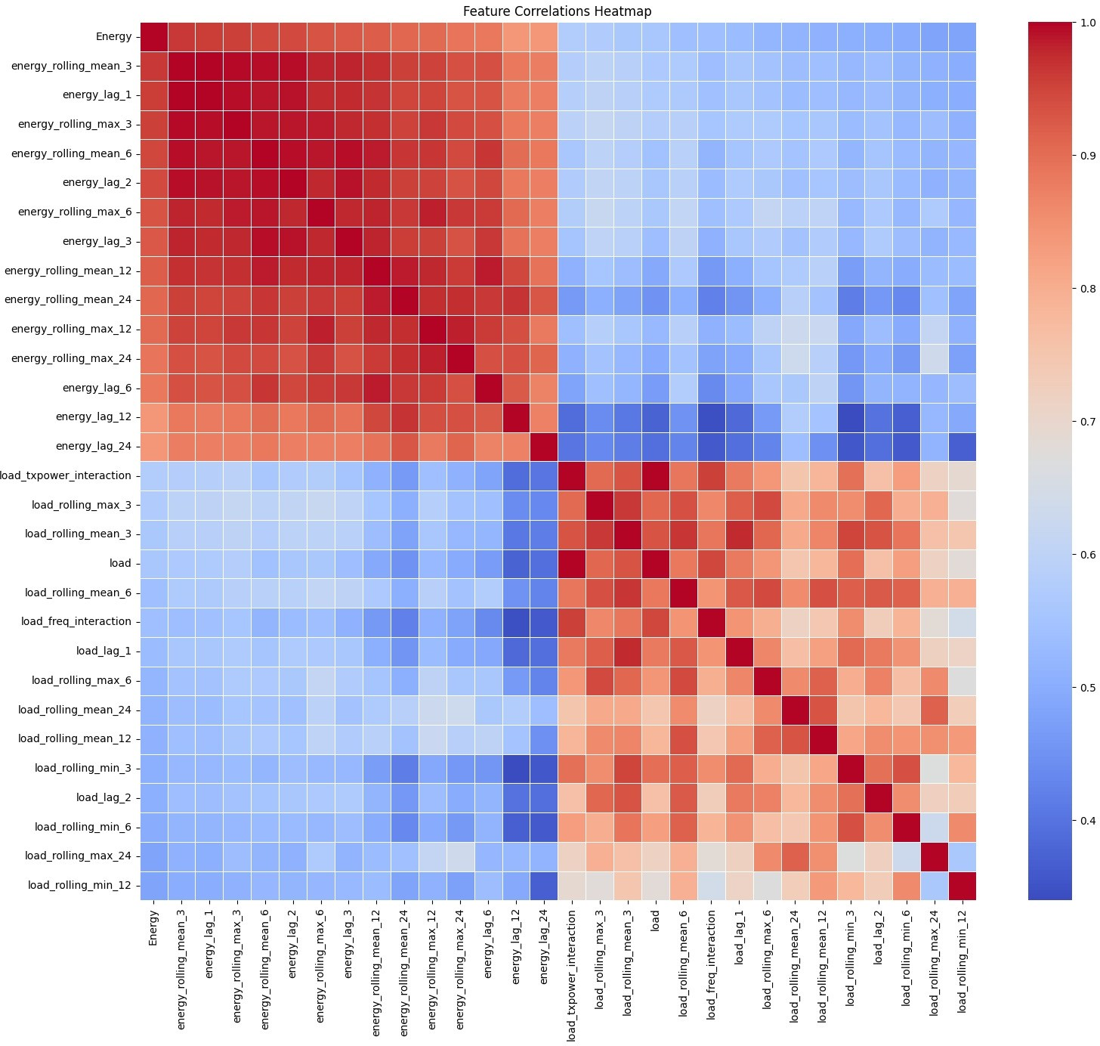
Fig. 9. Feature Correlations HeatMap.

- Classification Report
A detailed classification report provides classwise evaluation based on Precision, Recall, and F1-Score.
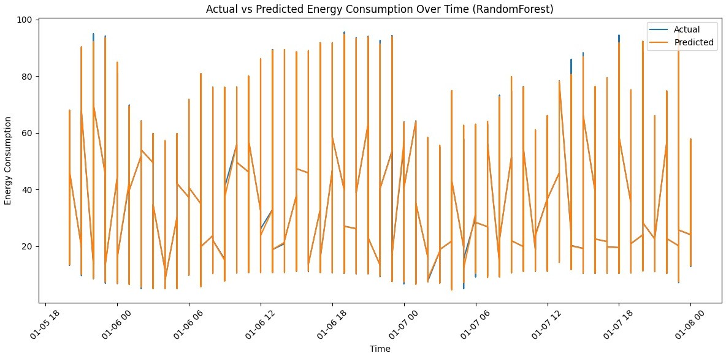

Fig. 10. Actual vs Predicted Energy Consumption Over Time.

The model has scored really well on all three metrics, which shows it’s making balanced and reliable predictions.

- Actual vs Predicted Energy Plot (Random Forest)
This scatter plot shows similarities or dissimilarities of the energy prediction from the Random Forest model using the real energy data from the test group.
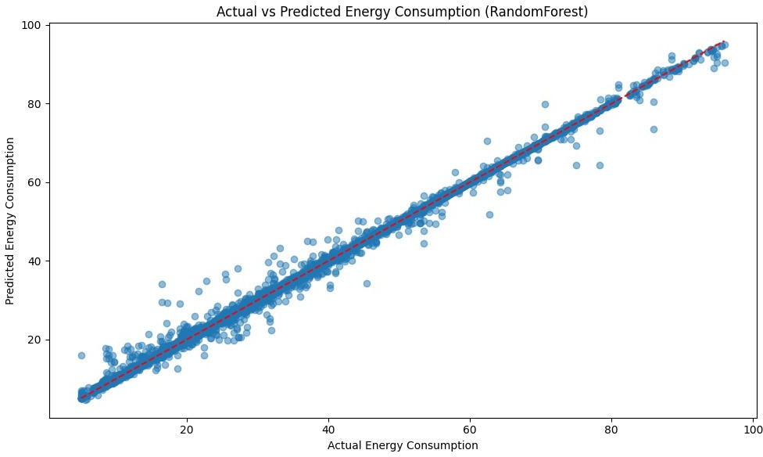

Fig. 11. Scatter Energy Plot.
The data points stick with red diagonal line, which shows that the Random Forest model is working well. Since points are tightly grouped along the line and the model does not show lots of errors and works well in difficult situations. Sure, there are some failures to catch but model still works well, even when things get complex with different values.
- Future Work And Analysis
- Energy Efficiency Optimization: Upcoming studies can design advanced methods to further minimize energy usage in radio access networks (RAN) and base stations (BS).
- Dynamic Network Configuration: Dynamic analysis plays a crucial role in evaluating the performance of any model, as it enables the examination of real-time data and supports accurate condition prediction. An adaptive network con- figuration that can respond to real-time traffic fluctuations and varying user demands provides a significant advan- tage in forecasting accurate scenarios and enhancing the effectiveness of predictive models.
- Resource Allocation Strategies: Intelligent allocation and distribution of resources that balance the trade-offs be- tween network performance and energy conservation can significantly enhance overall efficiency. Incorporating ad- ditional factors such as location and time in the alloca- tion process further strengthens the ability to optimize operations and achieve manifold improvements in energy utilization.
- Practical Deployments and Testing: Testing the model in real-world scenarios plays a vital role in identifying errors and ensuring successful validation. Collaboration with different telecommunication operators and the in- corporation of the model into their systems can provide valuable improvements and offer strong support for future developments.
- Ethical and Societal Implications: With the advancement of technology, the risk of cyberattacks poses serious threats to user privacy and confidentiality. These concerns must be carefully addressed while developing models to ensure that social and ethical norms are not compromised, as maintaining trust and safeguarding user interests remain of utmost importance.
References
- C. M. Bishop, Pattern Recognition and Machine Learning. Springer, 2006.
- T. Hastie, R. Tibshirani, and J. Friedman, The Elements of Statistical Learning: Data Mining, Inference, and Prediction. Springer, 2009.
- A. Ge´ron, Hands-On Machine Learning with Scikit-Learn, Keras, and TensorFlow. O’Reilly Media, 2019.
- Scikit-learn Documentation. Available: https://scikit-learn.org/stable/
- Towards Data Science (Medium). Available: https://towardsdatascience.com/
- Analytics Vidhya. Available: https://www.analyticsvidhya.com/
- N. Gupta, et al., “Enhanced Virtualization-Based Dynamic Bin-Packing Optimized Energy Management Solution for Heterogeneous Clouds,” Mathematical Problems in Engineering, vol. 2022, no. 1, p. 8734198, 2022.
- D. Gupta, et al., “Energy saving implementation in hydraulic press using industrial Internet of Things (IIoT),” Electronics, vol. 11, no. 23, p. 4061, 2022.
- K. Sathya and D. R. Kumar, “Energy efficient clustering in sensor networks using Cluster Manager,” in Proc. 2012 Int. Conf. on Computing, Communication and Applications, IEEE, 2012.
- R. K. Dhanaraj, et al., “Optimal clone attack detection model using an energy-efficient GSA based simulated annealing in wireless sensor networks,” Asian Journal of Research in Social Sciences and Humanities, vol. 6, no. 11, pp. 201–217, 2016.
- A. Zappone, M. Di Renzo, and M. Debbah, “A Survey on Machine Learning for Energy-Efficient Wireless Communications,” IEEE Com- munications Surveys & Tutorials, vol. 21, no. 2, pp. 1435-1478, Second Quarter 2019.
- I. Chih-Lin et al., “Toward green and soft: a 5G perspective,” IEEE Communications Magazine, vol. 52, no. 2, pp. 66-73, Feb. 2014.
- G. P. Fettweis, “The Tactile Internet: Applications and Challenges,” IEEE Vehicular Technology Magazine, vol. 9, no. 1, pp. 64-70, Mar. 2014.
- F. Boccardi, R. W. Heath, A. Lozano, T. L. Marzetta, and P. Popovski, “Five disruptive technology directions for 5G,” IEEE Communications Magazine, vol. 52, no. 2, pp. 74-80, Feb. 2014.
- Y. Zhang, S. Fowler, and S. G. Srinivasa, “Predicting Power Consumption of Cellular Base Stations using Machine Learning,” in Proc. 2019 IEEE International Conference on Communications (ICC), Shanghai, China, 2019, pp. 1-6.
- J. Wu, Z. Zhang, Y. Hong, and Y. Wen, “Deep Reinforcement Learning for Energy-Efficient Networking in 5G-and-Beyond,” IEEE Transactions on Network and Service Management, vol. 18, no. 2, pp. 1108-1121, June 2021.
- E. Bjo¨rnson, J. Hoydis, and L. Sanguinetti, “Massive MIMO Networks: Spectral, Energy, and Hardware Efficiency,” Foundations and Trends® in Signal Processing, vol. 11, no. 3-4, pp. 154-655, 2017.
- S. M. B. H. Shah, K. M. R. Alam, and M. A. Gregory, “Energy Efficient 5G Cellular Networks: A Survey,” in Proc. 2019 International Conference on Electrical, Computer and Communication Engineering (ECCE), 2019,
pp. 1-6.
- L. S. Van der Meulen, D. J. Van der Veen, and S. Pollin, “A Tutorial on Machine Learning for Energy-Efficient Networking in 5G,” IEEE Communications Surveys & Tutorials, vol. 23, no. 1, pp. 216-249, First Quarter 2021.
- R. Li, Z. Zhao, X. Zhou, J. Ding, Y. Chen, Z. Wang, and H. Zhang, “Intelligent 5G: When Cellular Networks Meet Artificial Intelligence,” IEEE Wireless Communications, vol. 24, no. 5, pp. 175-183, Oct. 2017.

